**Twiin4build Database**

We have use PostgreSQL database to store data. Below are the tables we have created to store input as well as output for the models.

**Database Tables:**

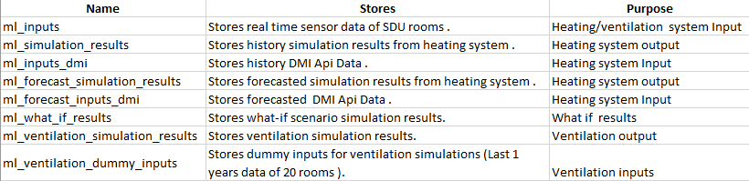

**Tables diagram:** To view the tables schema enlarge this to 350 percent.

